Week 2 Lab Task
Information Gathering (OSINT)
NIAI NAVTTC — Certified Ethical Hacker (CEH) Course
⚠ Important: All tasks must be performed only in your isolated virtual lab environment. Never test on real networks or systems without explicit written permission.

Task: Investigate a suspicious domain. Analyze domain registration details, check for potential malicious activities, and provide actionable intelligence for an incident response team.

▶ Choose a Safe Practice Domain
Use testphp.vulnweb.com — this is a deliberately vulnerable site made for training.
DO NOT target real websites or domains without explicit written permission.
▶ WHOIS Lookup — Find Domain Owner
Run in Kali terminal:
whois certifiedethicalhacker.com
Note the registrar, creation date, name servers, and contact details.
▶ DNS Enumeration
nslookup certifiedethicalhacker.com
host certifiedethicalhacker.com
▶ theHarvester — Gather Emails & Subdomains
theHarvester -d certifiedethicalhacker.com -b google
Replace example.com with your target domain. This finds emails and subdomains indexed by Google.
▶ Shodan — Check Exposed Services
Go to shodan.io in your browser.
Search the domain name or its IP address.
Note what ports and services are publicly visible (e.g. open port 22, 80, 443).
▶ Google Dorks — Find Indexed Pages
In Google browser, search:
site: certifiedethicalhacker.com
intitle:index.of certifiedethicalhacker.com
▶ Maltego (Optional — Visual Link Analysis)
Open Maltego from Kali applications menu.
Create a new graph and add the target domain as an entity.
Run transforms to visually map emails, IPs, and subdomains.
▶ Write Your Intelligence Report
Document the following findings in a structured report:
- Who owns the domain? (WHOIS data)
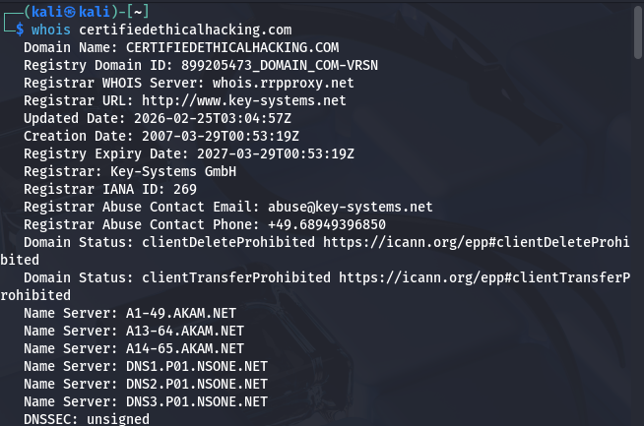
- What IP addresses are associated?
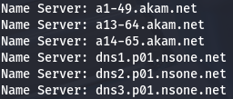
- What emails or subdomains were found?
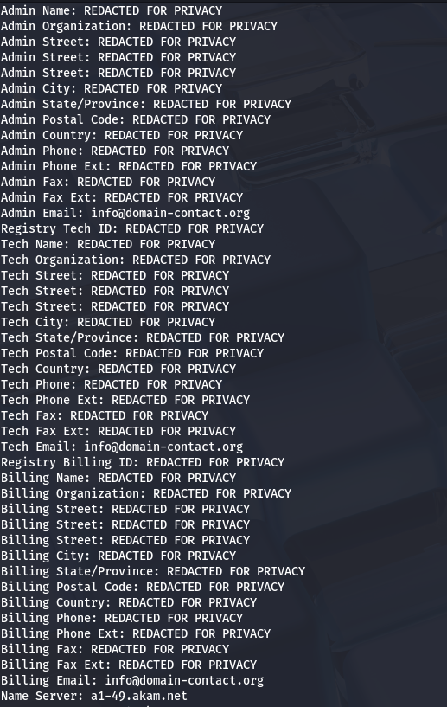
- What ports/services are exposed on Shodan?
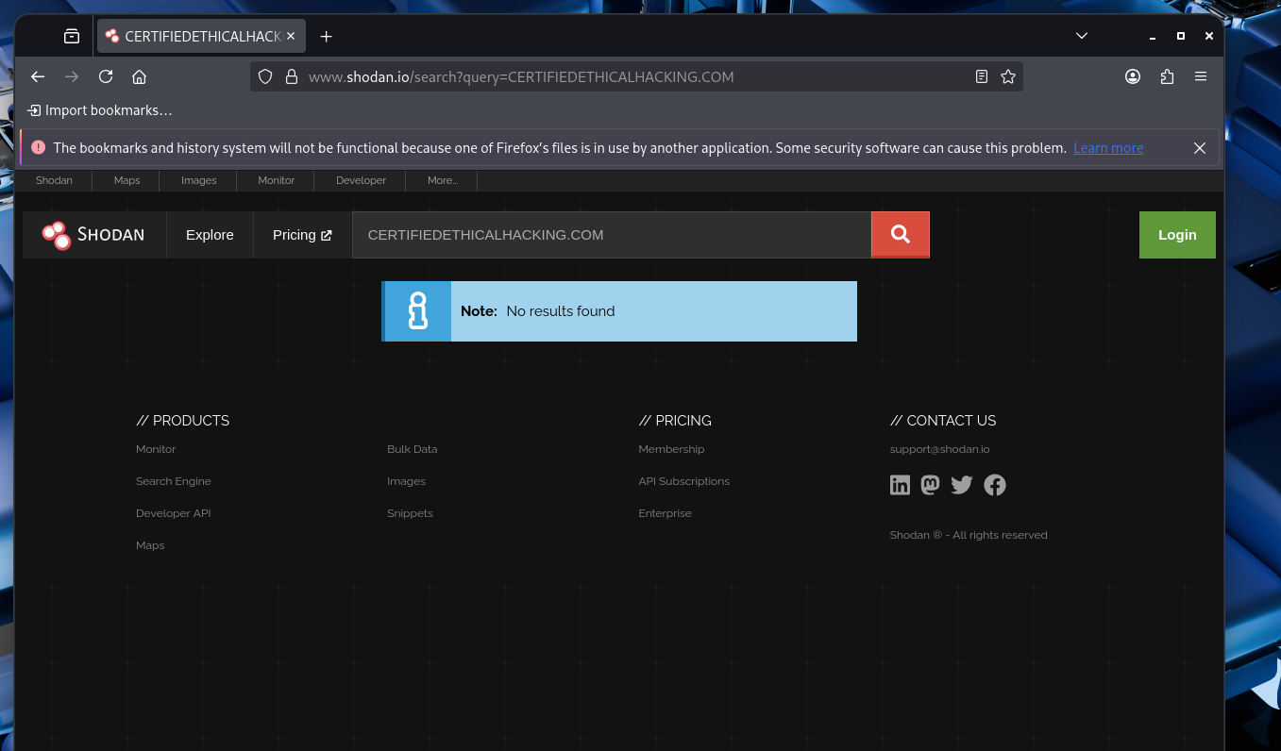
- Any suspicious indicators?
Couldn’t find any…

🎯 Goal: Produce a structured intelligence report on a domain including ownership, DNS records, exposed services, and any suspicious indicators of compromise.

